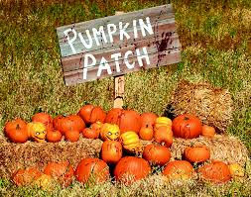
Service Hours
Opportunity

When: Saturday, October 14th
Time: 8:30 am – 11:30 am
Location: First United Methodist Church
10000 Central Ave, Oak Lawn, IL

Your help is needed to unload pumpkins. Snacks and water will be provided.

For more information please call
Shellie Cholke at 708-372-5295

