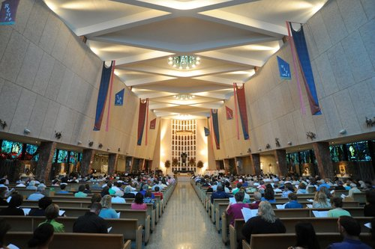
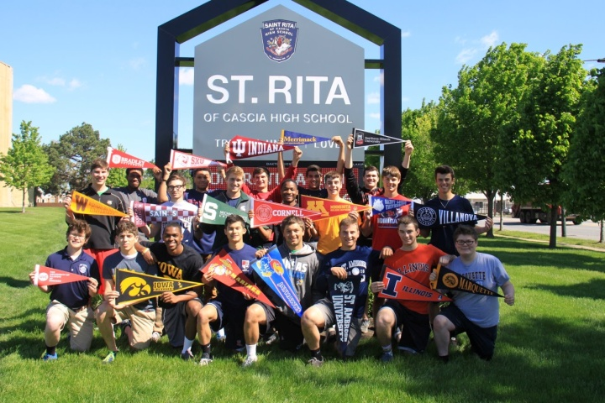
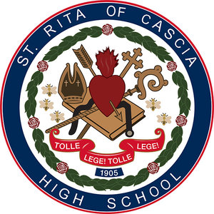
An Evening with St. Rita
for St. Linus Families

Date: Wednesday, October 18 at 7:00pm
Located at: Deja Brew Bar & Grill
Address: 5219 95th Street, in Oak Lawn
Join us to learn more about the wonderful opportunities available for your son as a St. Rita Mustang!
You will be able to meet members of the St. Rita Administration including:
Fr. Paul Galetto, O.S.A., Head of School
Mr. Brendan Conroy, Principal
Mr. Ed Leiser ’04, Admissions Director
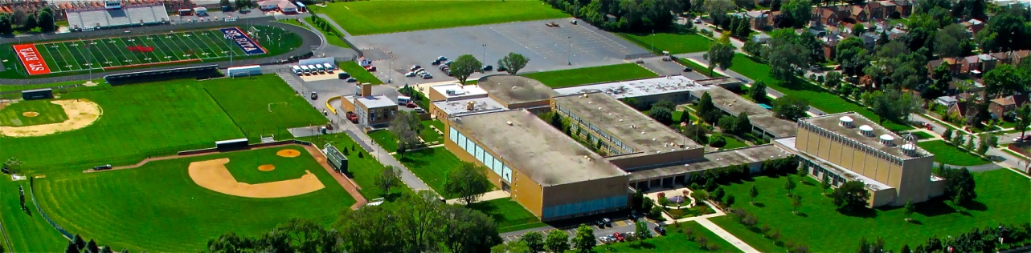
Please RSVP to Mr. Ed Leiser ’04, Admissions Director at: eleiser@stritahs.com or 773-925-7482

