St Linus Car Decals Now Available!!!!
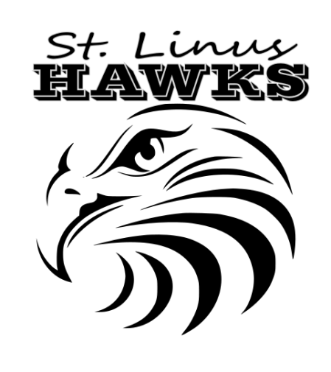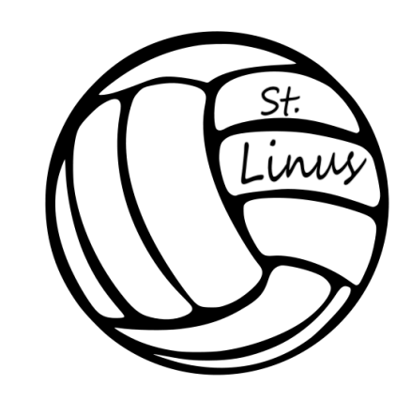
$8each  ENTER QTY: | Basketball | Cheer | Football | Golf | Hawks | Soccer | Linus School | Volleyball 1 | Volleyball 2
White

Blue

Golden

Sparkle

SUBTOTAL:

 |  |  |  |  |  |  | TOTAL:
*These car decals are roughly 6-8”, made with professional outdoor vinyl, and rated to last in all weather conditions for at least 6 years. Instructions on how-to-apply the decals are included with every purchase.
Made by Custom Creation- Vinyl Decals & More!
www.facebook.com/customcreation4u

Name:____________ Grade:__________ Classroom:____________
Please pay by cash or checks payable to St Linus FTC
