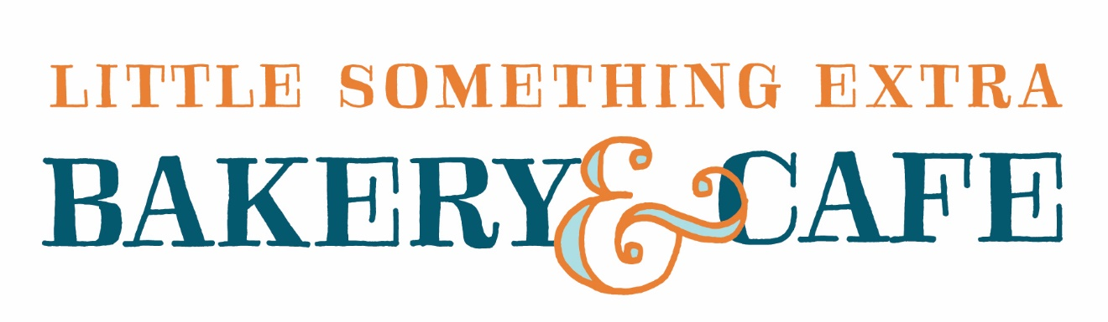
St. Linus Families – Little Something Extra is Oak Lawn’s newest bakery/café – located in the Jewel Parking lot on 103rd Street. Look for the Blue Door over by Clancy’s.
Join us at lunchtime after school on Thursday August 23rd. Wear your uniform or spirit wear, to get a hot dog and cookie for $1.50. Offer good for students only. Limit one per child.
(708) 552-6882. 4616 W. 103rd Street.

St. Linus Families – Little Something Extra is Oak Lawn’s newest bakery/café – located in the Jewel Parking lot on 103rd Street. Look for the Blue Door over by Clancy’s.
Join us at lunchtime after school on Thursday August 24th. Wear your uniform or spirit wear, to get a hot dog and cookie for $1.50. Offer good for students only. Limit one per child.
(708) 552-6882. 4616 W. 103rd Street

