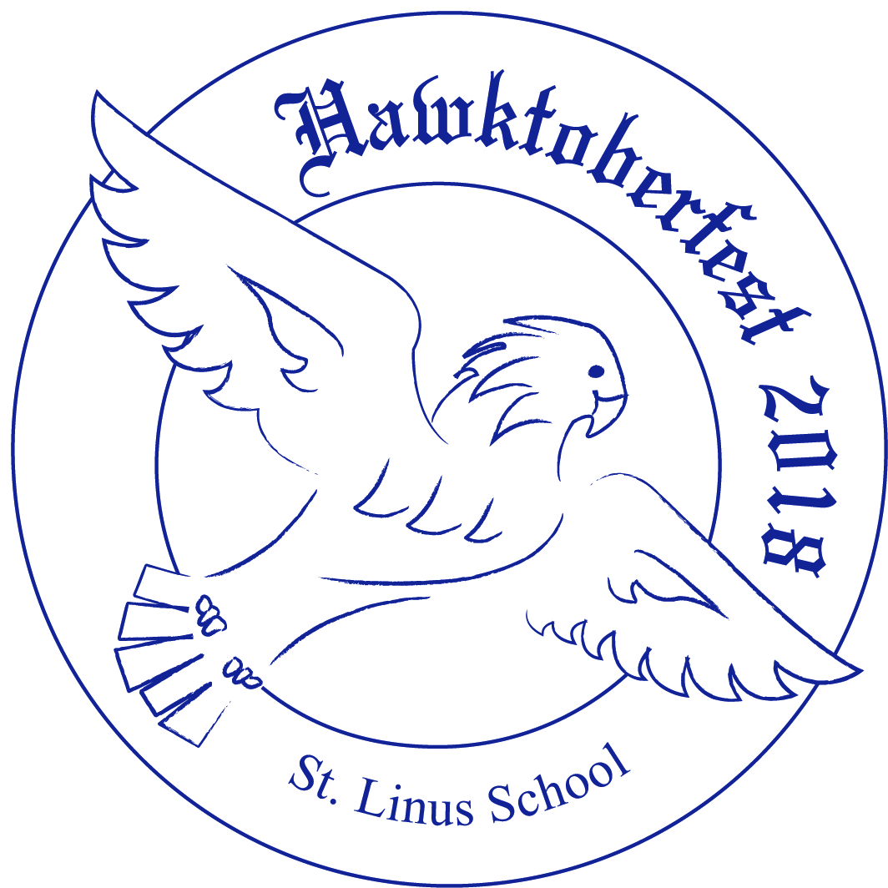
Hawktoberfest
September 15th, 2018
4pm-11pm on Hawk Field

Join us for the 8th annual Hawktoberfest! Many classic activities return, including jumpies, cupcake tent, face painting, and kiddie games. In addition, we have two NEW ATTRACTIONS THIS YEAR: Dave DiNaso’s Traveling World of Reptiles (5:30-6:45pm) and Nerf Wars (6:30-9:30pm). Entertainment includes LIVE MUSIC by H.R.S. Inc. & The Dancing Noodles. Tickets are $10 each and will be sold at lunch from 9/6-9/14. Ticket prices will go up to $15 at the door on 9/15, so make sure to get yours today!

Student name: ___________________________________________ Rm. # ____________

# of tickets _______________

Hawktoberfest
September 15th, 2018
4pm-11pm on Hawk Field

Join us for the 8th annual Hawktoberfest! Many classic activities return, including jumpies, cupcake tent, face painting, and kiddie games. In addition, we have two NEW ATTRACTIONS THIS YEAR: Dave DiNaso’s Traveling World of Reptiles (5:30-6:45pm) and Nerf Wars (6:30-9:30pm). Entertainment includes LIVE MUSIC by H.R.S. Inc. & The Dancing Noodles. Tickets are $10 each and will be sold at lunch from 9/6-9/14. Ticket prices will go up to $15 at the door on 9/15, so make sure to get yours today!

Student name: ___________________________________________ Rm. # ____________

# of tickets _______________

