SCIP – CALENDAR – OCTOBER 2018
Envelope Orders are due by 9am Monday morning in the Parish Rectory
*** Tuesday if there is a holiday
Monday – Oct 1st Envelope Orders Due 9am
Tuesday- Oct 2nd Cash & Carry 6-7 pm
Thursday- Oct 4th Cash & Carry 6-7pm

Tuesday Oct 9th Envelope Orders Due 9 AM
Tuesday, Oct 9th Cash & Carry 6pm -7pm
Thursday, Oct 11 Cash & Carry 6pm -7pm

Monday, Oct 15th Envelopes Orders Due by 9AM
Tuesday, Oct 16th Cash & Carry 6pm -7pm
Thursday, Oct 18th Cash & Carry 6pm -7pm

Monday, Oct 22nd Envelope Orders Due by 9AM
Tuesday, Oct 23rd Cash & Carry 6pm -7pm
Thursday, Oct 25th Cash & Carry 6pm -7pm

Saturday, Oct27th Cash & Carry 9:15am to 11am

Monday, Oct 29th Envelope Orders Due 9am

Tuesday, Oct 30th Cash & Carry 6pm – 7pm

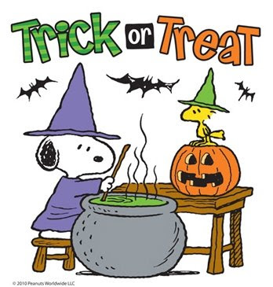
Happy Halloween

