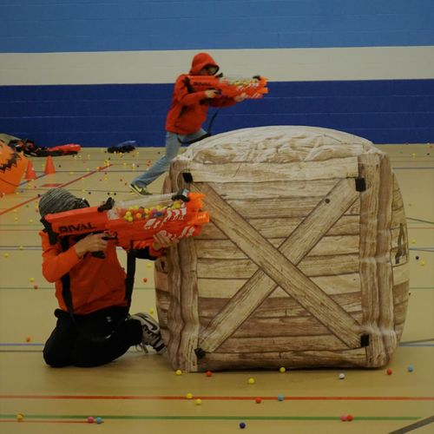

St Linus FTC Mother/Son NERF War
Friday January 18, 2019 from 6-9 pm
St Linus Gym
$20 per person
Includes Nerf War, pizza and drinks
All Equipment is Provided including *Blasters, Masks, Team Color Jerseys, and Bunkers.
We will be breaking the event up into "shifts" so the little kids aren't playing at the same time as the older kids

Please return this slip and payment (cash or check payable to St Linus FTC) to the school office by 1/11/2019 or register and pay on line (there is a small convenience fee) at https://www.eventbrite.com/e/motherson-nerf-wars-tickets-47858652518

Family Name:_______________ Number of Attendees:__________

