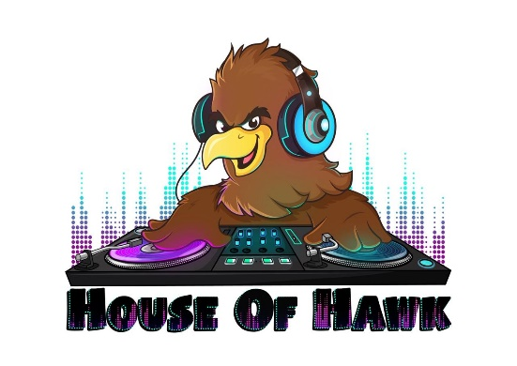
Friday, May 31, 2019 8pm-12am
115 Bourbon St, Merrionette Park IL
Sponsorship Opportunities for St. Linus House of Hawk Music Fest
Proceeds from this event will be dedicated to the St Linus School Music Program
Sponsorship Levels at a Glance:
Sponsor benefit | Turntable | Mixer | Scratch | Headphones | Bassline | DJ Booth
4 Complimentary VIP admissions & 6 weeks in parish bulletin. Hyperlink from event website to donor site
2 Complimentary admissions & 4 weeks in parish bulletin
1 Complimentary Admission , Lawn Sign & 3 weeks in parish bulletin
1 Complimentary Admission & 2 weeks in parish bulletin
Logo on Website and Social Media
Name on Event Banner Signage
Subject to print Deadline | $100 | $250 | $350 | $500 | $1,000 | $1500+
**Please make checks payable to St. Linus School Forms can be dropped off or mailed to rectory or school

Print Deadline for Event is May 17, 2019

Sponsorship at the DJ Booth Level ($1,500 cash or combination cash and in-kind donation)
Sponsors at this level will receive a 4 VIP admission tickets to event, a link with logo on our website, their logo/name on a lawn sign, social media advertising with link to sponsor’s website, six weeks mention in the parish bulletin and event day logo on banner and table at event.

Sponsorship at the Bassline Level ($1,000 cash or combination cash and in-kind donation)
Sponsors at this level will receive a 2 admission tickets to event, logo on our website, their logo/name on a lawn sign, social media advertising with link to sponsor’s website, four weeks mention in the parish bulletin and event day logo on banner.

Sponsorship at the Headphones Level ($500 cash or combination cash and in-kind donation)
Sponsors at this level will receive a 1 admission tickets to event, logo on our website, their logo/name on a lawn sign, social media advertising with link to sponsor’s website, three weeks mention in the parish bulletin and event day logo on banner.

Sponsorship at the Scratch Level ($350 cash or combination cash and in-kind donation)
Sponsors at this level will receive a 1 admission tickets to event, logo on our website, social media advertising with link to sponsor’s website, two weeks mention in the parish bulletin and event day logo on banner

Sponsorship at the Mixer Level ($250 cash or combination cash and in-kind donation)
Sponsors at this level will receive logo on our website, social media advertising with link to sponsor’s website, and event day name on banner.

Sponsorship at the Turntable Level ($100 cash or combination cash and in-kind donation)
Sponsors at this level will receive name on event day on banner.

Sponsorship Opportunities for St. Linus House of Hawk Music Fest

2019 House of Hawk Sponsorship Form

Sponsor Information: Name:______________________________________________________ Company:___________________________________________________ Address:____________________________________________________ City:_________________ State:__________________ Zip:__________ Phone Number:___________________ email:_____________________

Sponsorship level: Donation:
Cash Amount:_______________
In Kind Donation: _______________
In Kind Donation value:____________
DJ Booth
Bassline
Headphones
Scratch
Mixer
Turntable

St. Linus thanks you for your generous donation to our annual spring fundraiser. We are a 501c3 tax deductible charity. Upon request we can provide our sponsors with a tax receipt for their donation.

Please email: stlspringfundraiser@gmail.com when requesting a tax receipt for your donation with ‘Sponsor Tax Receipt’ in the subject line.

Logo Artwork should be sent to: stlspringfundraiser@gmail.com

Thank you very much for your donation!

Sincerely,

St Linus House of Hawk Committee

