St Linus Socks are back!!
High Performance Basketball socks built to perform in every quarter! Designed to keep a consistently delivered level of comfort, this sock includes an arch support and cushioned bottom.

Available in three sizes:
Size: 5-7 (Kids Shoe size 8-2 ½)
Size: 7-9 (Kids Shoe size 2-5 ½)
Size: 9-11 (Adult Shoe size 6-11)

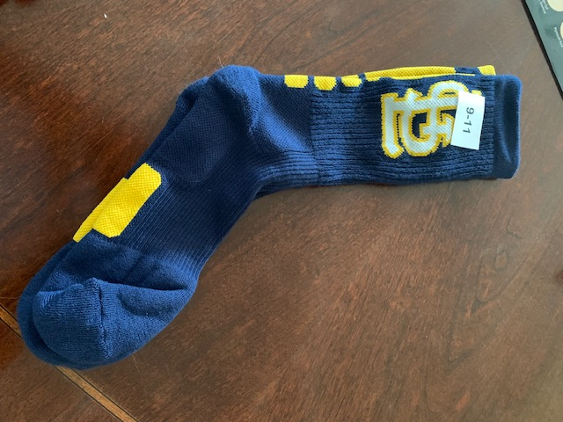

$10 per pair

Socks will be sent home with students the week of 9/16/19

Student Name:__________________________________________
Teacher/Classroom:____________________________________
Size:______________________
Number of Pairs:______________
Please make all checks payable to St Linus FTC
