ST. LINUS PLAYERS PRESENT

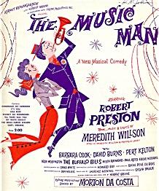

MUSIC MAN JR.
AUDITIONS
SATURDAY, JANUARY 25
10:30-12:00
SUNDAY, JANUARY 26
11:00-1:00
CARDIFF CENTER

