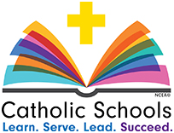

CELEBRATE SERVICE

Our St. Linus students will be collecting items to donate to our local food pantries and organizations.

Students may bring in their items on Wednesday, January 29th, 2020.

Preschool - coloring books & crayons

Kindergarten – 3rd grade - travel size toiletries

4th & 5th grade - mittens, gloves & hats

6th-8th grade – nonperishable food items

