WE ARE ST LINUS Southside Irish Parade

Come show off your St. Linus pride and help us represent our school at this years Southside Irish Parade, Sunday March 15th! Please fill out your order and bring cash or check (St. Linus School) into the main office. Order forms are due no later than February 20th. More information on our float will be given out closer to parade day. Whether you’re walking or watching, it will be a great day to be a Hawk!
Kelly green t-shirt or hoodie, WE ARE ST LINUS in white, shamrocks are white and 1 navy blue in the middle
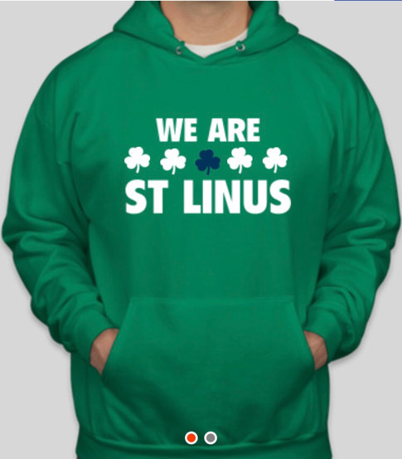
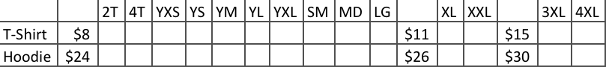
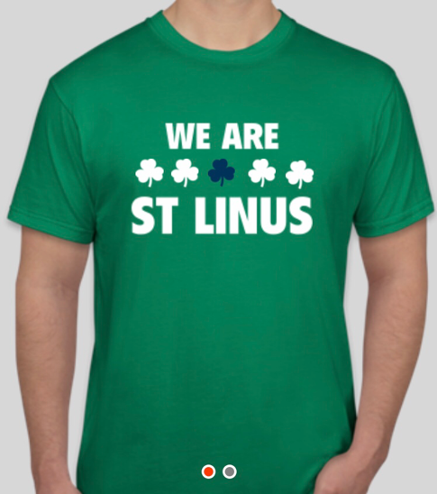
FAMILY NAME:
ROOM NUMBER:
$ TOTAL:

