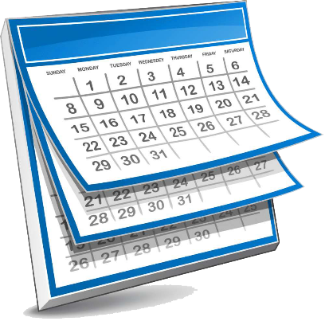
Saint Linus School
Important Calendar Dates
2021-2022

These dates are intended to assist our parents with planning during the 2021-2022 school year. A complete calendar will be sent home each month with specific school events and parent meetings noted.

Extended Day starts on August 23, 2021 and runs through June 7, 2022.
Extended Day is available on “Early Dismissal at 1:30” days unless noted.
NO Afterschool Extended Day on November 23, December 22, and March 10.
___________________________________________________________________

August 19 – Welcome Back Day-4:00-7:00PM
August 23 – First Day of School (K-8) – Dismissal at 1:30PM
August 26 – First Day of Pre-K

September 1 – Faculty Meeting – Early Dismissal at 1:30
September 2 –Junior High Parent Back-to-School Night – 6:30 pm
September 6 – No School – Labor Day
September 18- Hawktoberfest

October 6 – Faculty Meeting – Early Dismissal at 1:30
October 8 – No School – Professional Development Day
October 11 – No School – Columbus Day

November 3 – Faculty Meeting – Early Dismissal at 1:30
November 6 – 5K Race
November 23 – P/T Conferences – ½ Day – Dismissal at 11:30 – No Extended Day
November 23 – Parent Teacher Conferences – 12:30 – 7:30
November 24, 25, 26 – No School – Thanksgiving Break

December 1 – Faculty Meeting – Early Dismissal at 1:30
December 22 – Christmas Break Begins with Dismissal 11:30
December 23 thru January 4 – No School – Christmas Break

-over-

January 5 – School Resumes
January 5 – Faculty Meeting – Early Dismissal 1:30
January 17 – No School – Martin Luther King Day
January 30 – Catholic Schools Week Begins

February 2 – Faculty Meeting – Early Dismissal at 1:30
February 18 – No School- Professional Development Day
February 21 – No School – President’s Day

March 2 – Faculty Meeting – Early Dismissal at 1:30
March 10 – P/T Conferences – ½ Day – Dismissal at 11:30 – No Extended Day
March 10 – Parent Teacher Conferences – 12:30 – 5:00
March 11 – No School

April 6 – Faculty Meeting – Early Dismissal at 1:30
April 14 – No School – Holy Thursday
April 15 – No School – Good Friday
April 14 thru April 22 – No School – Easter Break
April 25 – School Resumes – Dismissal at 2:40

May 4 – Faculty Meeting – Early Dismissal at 1:30
May 27 – Graduation Class of 2022
May 30 – No School – Memorial Day

June 2 – Preschool Celebration 9:30-12:00
June 3 – Kindergarten Celebration 9:30 AM
June 7 – Field Day/Last Day of School (1-7)
June 8 thru June 14 – Emergency Days (if needed)

