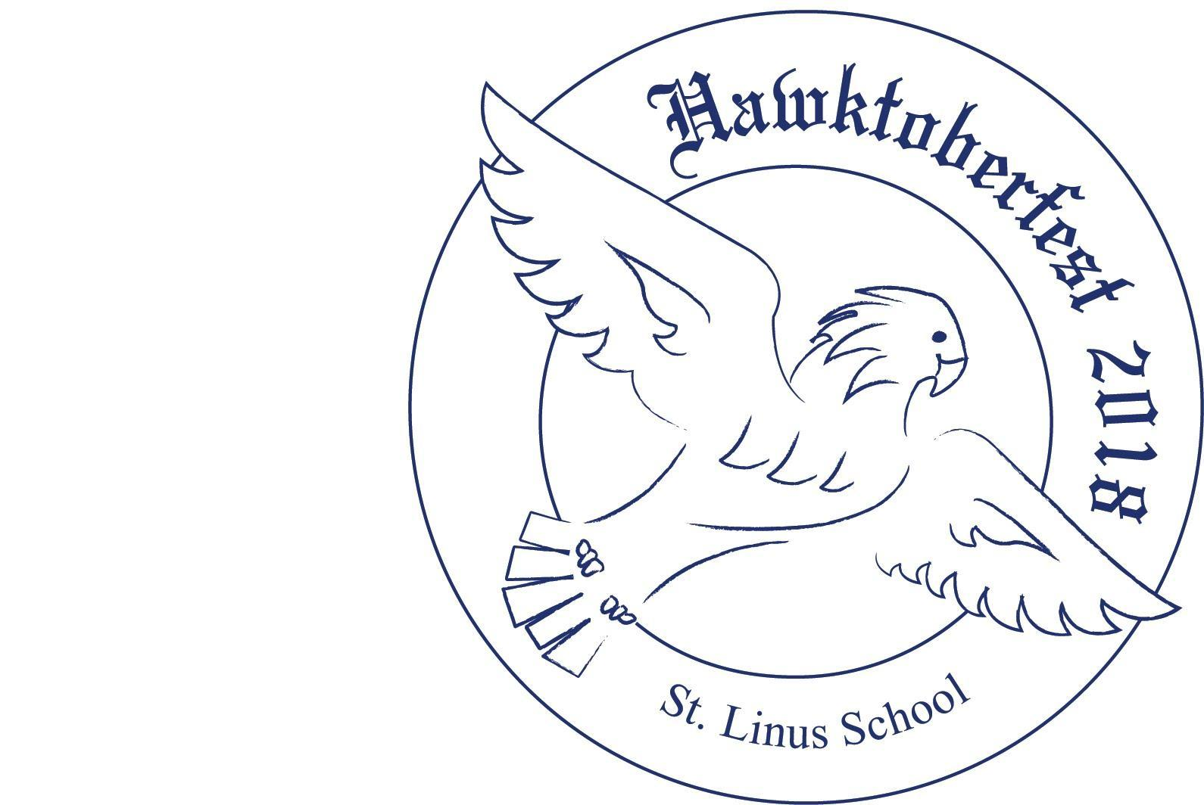

Hawktoberfest
September 18, 2021
4pm-11pm on Hawk Field

Join us for the 11th annual Hawktoberfest! We are so excited to be able to hold Hawktoberfest on the St. Linus Hawk field again! The day will include interactive inflatables, a cupcake decorating tent, face painting, beer tent, and Dave DiNaso’s Traveling World of Reptiles (6-7:15pm). Entertainment includes LIVE MUSIC by H.R.S. Inc. & O’Leary’s Lantern featuring our own Linus dad, Dave Harrington! Concessions will be sold, and delicious barbecue and tacos will be available from Big Joe’s Blazin’ BBQ. Tickets are $10 each. Ticket prices will go up to $15 at the door.

Student name: _____________________________ Rm. # ______ # of tickets _____

Hawktoberfest
September 18, 2021
4pm-11pm on Hawk Field

Join us for the 11th annual Hawktoberfest! We are so excited to be able to hold Hawktoberfest on the St. Linus Hawk field again! The day will include interactive inflatables, a cupcake decorating tent, face painting, beer tent, and Dave DiNaso’s Traveling World of Reptiles (6-7:15pm). Entertainment includes LIVE MUSIC by H.R.S. Inc. & O’Leary’s Lantern featuring our own Linus dad, Dave Harrington! Concessions will be sold, and delicious barbecue and tacos will be available from Big Joe’s Blazin’ BBQ. Tickets are $10 each. Ticket prices will go up to $15 at the door.

Student name: _____________________________ Rm. # ______ # of tickets _____

