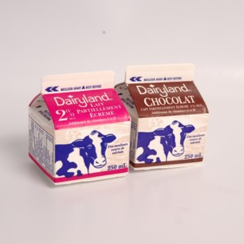
SCHOOL MILK ORDER FORM
If you would like to purchase milk for your child, please complete the form below and return by August 27, 2021.
The price of milk is $50.00 per student and will be billed on your Smart Tuition Account.

Milk will begin the first week of school

Family Name:_____________________
Student: ________________Gr. Room White or Chocolate
Student: ________________Gr. Room White or Chocolate
Student: ________________Gr. Room White or Chocolate

