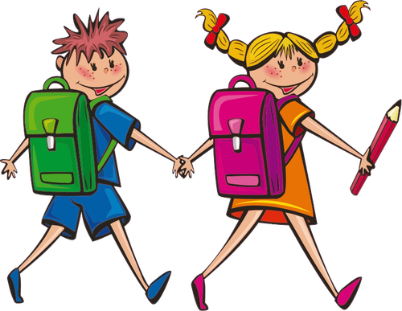

Mrs. Kokaska’s 3-Year Old Preschool Supply List

**Please make sure the Folder, School Bag, Extra Clothes Bag and Rest Towel/Mat is labeled with your child’s name on it with a permanent marker.**

- School Bag(Standard Size)
- 1 two pocket folder (Please make sure name is on the front of folder)
- 2 Boxes of 24 washable crayons
- 6 Elmer small glue sticks
- 2 Rolls of Paper towels
- 2 Container of Baby Wipes
- 1 Set of Extra clothes in a Ziplock Bag with Your Child’s Name
- 1 box of Kleenex
- 1 Box of 8 Wide tip Washable Marker
- 4 Fine tip dry erase Markers
- Girls: 1 box sandwich size of Ziplock bags
- Boys: 1 box gallon size ziplock bags
- Rest towel/Mat Beach towel works best! It must be able to fit in their cubby!!!(Pillows and stuffed animals are not allowed)
- 2 containers of Clorox Wipes

